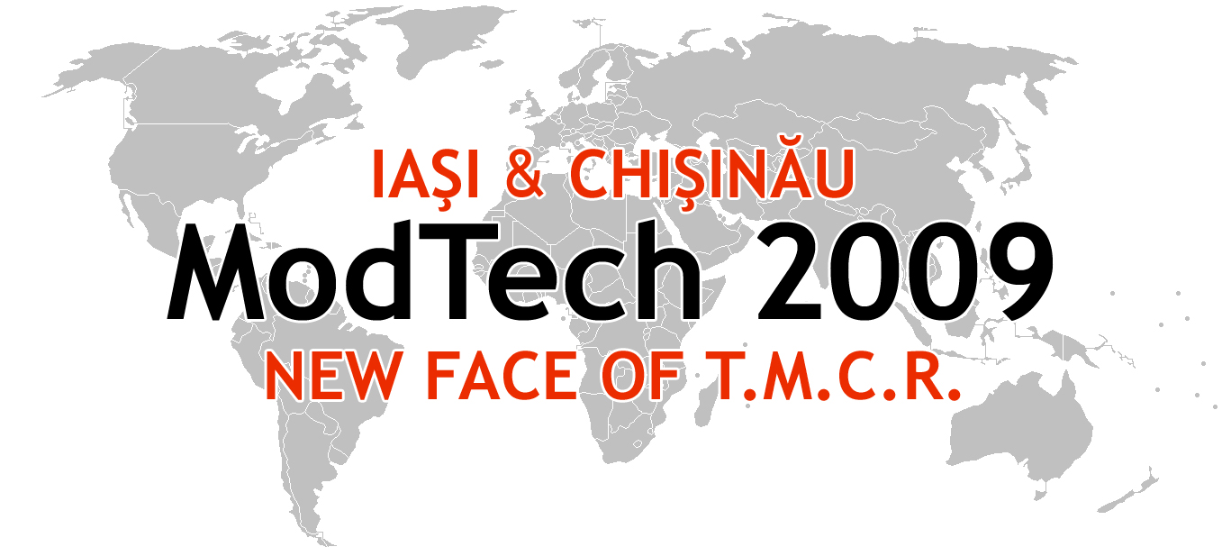

ModTech International Conference - New face of TMCR
Modern Technologies, Quality and Innovation - New face of TMCR
21-23rd May 2009
http://www.modtech.ro
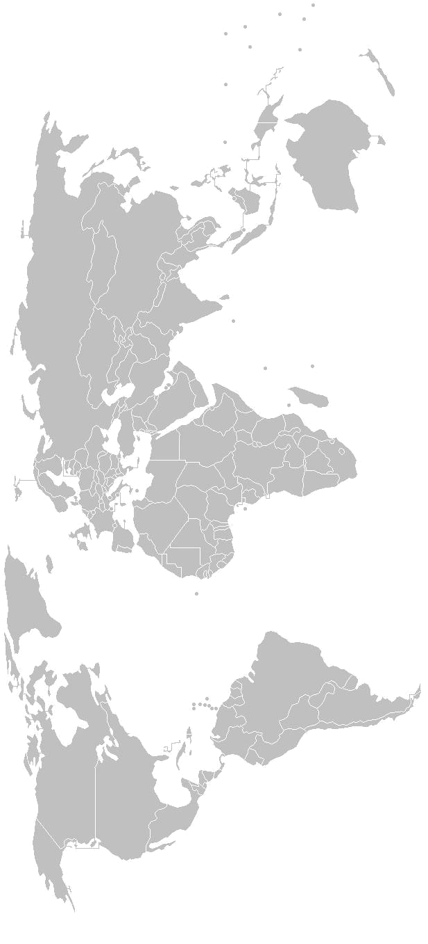

SECTION 2
Manufacturing

B-1-08, Laboratory of Computer Aided Design-1

Chair: Prof. Octavian Lupescu, Ph.D.
Co-Chair: Assoc. Prof. Gheorghe Cretu, Ph.D.
Secretary: Ramona Popa, Ph.D. Student

Thursday  May 21 | Papers & Authors
15²⁰-15³⁵ | Considerations for optimizing the process of cutting thread with taps  Timofte Chirugu Gianina, Paraschiv Dragos, Chirugu Marius, Stepan Kristoforian
15³⁵-15⁵⁰ | About some of slide bearings’ characteristics,term to the materials which are made from  Luminita Agachi, Gheorghe Nagit, Oana Dodun, & Carmen Burlibasa
15⁵⁰-16⁰⁵ | Vibrations analysis of a heavy truck with two identical engines - Anghel Chiru,Sorin Vlase, Carol Ambrus, Dumitru Nicoară,Pirnă Ioan &Anca Stanciu
16⁰⁵-16²⁰ | Improvement of the feeding screw tip manufacturing in the case of the plastic injection machines  Flavius A. Ardelean, Ştefan Mihăilă & Sorin Ilie
16²⁰-16³⁵ | Analysis of transmitted regimes of wedge-belt variators  Bahadirov Gayrat, Rizaev Anvar, Nabieb Muhammadjon & Bahadirov Kudrathon
16³⁵-16⁵⁰ | Some aspects comparative concerning the diameter errors in bar turning  Mihai Boca, Gheorghe Nagîţ, Iolanda Poşchin, Sorin Popa
16⁵⁰-17⁰⁵ | Improoving the nonstandard gears transmission performances by using different generation gear rack  Flavia Chira, Lucian Butnar, Mihai Banica& Liliana Dragan
17⁰⁵-17²⁰ | Optimising the gears with asymmetric involute teeth by modification the generation gear rack angles  Flavia Chira, Mihai Banica, Lucian Butnar & Liliana Dragan
17²⁰-17³⁵ | Study of stress state in an experimental device  for precision shear cutting  Ruxandra Cioară & Romeo Cioară
17³⁵-17⁵⁰ | The constructive analysis of the borer heads for the rotative boring  Dumitrescu Iosif, Cozma Bogdan-Zeno
17⁵⁰-18⁰⁵ | Optimizing the structure of a ship transverse section  Dumitru Dragomir, Leonard Domnisoru & Alexandru Ioan
18⁰⁵-18²⁰ | Decrease of cutting forse irregularity at natural stone grinding  Igor Gorobets, Alexander Mikhaylov, Mikola Golubov, Illia Navka
Friday  May 22 | Papers & Authors
9⁰⁰-9¹⁵ | Theoretical and experimental researches regarding  finding out of a regresion functions at edm manufacturing  Emilia Iuras, Oana Anton & Sanda Cretu
9¹⁵-9³⁰ | Influence of the grinding parameters on the characteristics of gears teeth outer layer. First part  Sergiu Mazuru
9³⁰-9⁴⁵ | Calculation of a new regression relation of the cutting force when enlarging the holes in steel OLC45  Constantin Minciu, Maturin Sime & Aurelian Vlase
9⁴⁵-10⁰⁰ | Calculation of a new regression relation of the cutting moment when enlarging the holes in steel OLC45  Constantin Minciu, Aurelian Vlase & Maturin Sime
10⁰⁰-10¹⁵ | Frontal ring tool  Ionuţ Popa, Gabriel Dura, Virgil Teodor, Nicolae Oancea
10¹⁵-10³⁰ | Theoretical research on the dynamics of the tractor-blade of unsnowing worksb  Vasile Padureanu, Mirabela Ioana Lupu
10³⁰-10⁴⁵ | Total productive maintenance architecture for future machining processes Eugen Pămîntaş & Cristian-Gheorghe Turc
10⁴⁵-11⁰⁰ | Using the technological equipments availability sill to evaluate their live cycle time  Ionut Popa, Octavian Lupescu, Ramona Popa & Ovidiu Sava
11⁰⁰-11¹⁵ | Upon the spare parts stocks utilization in techological equipments predictive maintenance  Ramona Popa, Ionut Popa, Octavian Lupescu & Cristian Ulianov
11¹⁵-11³⁰ | Model mechanic approach of “ divided mass in n bar“ for the calculus of vibration amplitude of ball mills  Mariana Adriana Prichici, Liliana indrie
11³⁰-11⁴⁵ | Vibration amplitude as a function of filling ratio and dimensions of balls mills Mariana Adriana Prichici, Liliana indrie
11⁴⁵-12⁰⁰ | experimental study of friction coefficient in orthogonal milling  Francisco Santos, Manuel San Juan, Oscar Martin, Roberto Lopez & Florin Negoescu
12⁰⁰-12¹⁵ | Study regarding thin plywood structure as a determinant factor of their elasticity  Rodica Sava
12¹⁵-12³⁰ | Influence of the grinding parameters on the characteristics of gears teeth outer layer. Second part  Ion Bostan, Sergiu Mazuru
Lunch break
15²⁰-15³⁵ | Calculation of a new regression relation of the cutting moment when enlarging holes in stainless steel 2MoNiCr175  Maturin Sime, Constantin Minciu & Aurelian Vlase
15³⁵-15⁵⁰ | Considerations concerning the work in dynamic regime of diesel engines  Mihai Simionov
15⁵⁰-16⁰⁵ | Method for the control of the geometric and constructive elements of the cutting tools  Eugen Străjescu & Olimpia Pavlov
16⁰⁵-16²⁰ | Determination of the regression relation of the cutting moments for widening of the stainless steel 4NiCr180  Aurelian Vlase, Ovidiu Blăjină & Maturin Sime
16²⁰-16³⁵ | Determination of the regression relation of the cutting forces for turning of the stainless steel 20MoCr130  Aurelian Vlase, Ovidiu Blăjină & Maturin Sime
16³⁵-16⁵⁰ | Calculation of a new regression relation of the cutting force when enlarging holes in stainless steel 2MoNiCr175  Maturin Sime, Aurelian Vlase & Constantin Minciu

